Bottom Base of a Cylinder
# Source: AI Source: Provided by: [Data Path: Persons Table -> ID Column: 1, Name_En Column: Motasem Essam] -> From: [ChatGPT] on [7/25/2026]
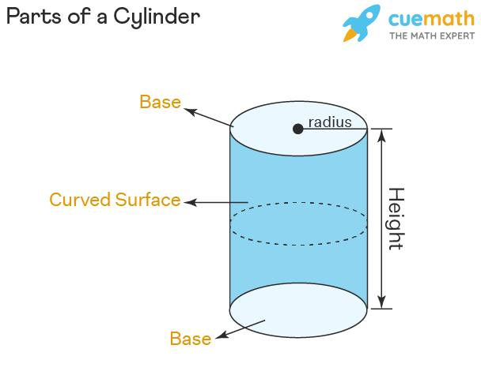
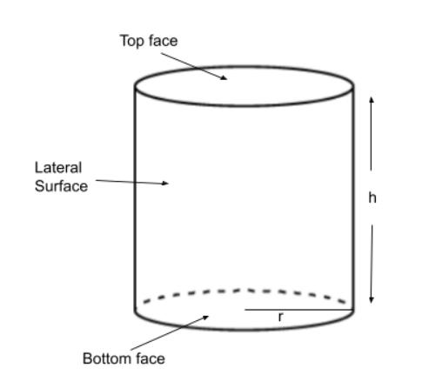


Definition
# Source: AI Source: Provided by: [Data Path: Persons Table -> ID Column: 1, Name_En Column: Motasem Essam] -> From: [ChatGPT] on [7/25/2026]
The bottom base of a cylinder is the flat face located at the lower end of the cylinder. In a circular cylinder, it is a circular region parallel and congruent to the top base.
The bottom base has the same radius, diameter, circumference, and area as the top base. The perpendicular distance between the bottom and top base planes is the cylinder's height.
For a circular cylinder:
$$\boxed{A_{\text{bottom}}=πr^{2}}$$

Simple Definition
# Source: AI Source: Provided by: [Data Path: Persons Table -> ID Column: 1, Name_En Column: Motasem Essam] -> From: [ChatGPT] on [7/25/2026]
The bottom base is the flat circular face at the bottom of a cylinder, like the underside of a can.

Geometric Representation and Components
# Source: AI Source: Provided by: [Data Path: Persons Table -> ID Column: 1, Name_En Column: Motasem Essam] -> From: [ChatGPT] on [7/25/2026]
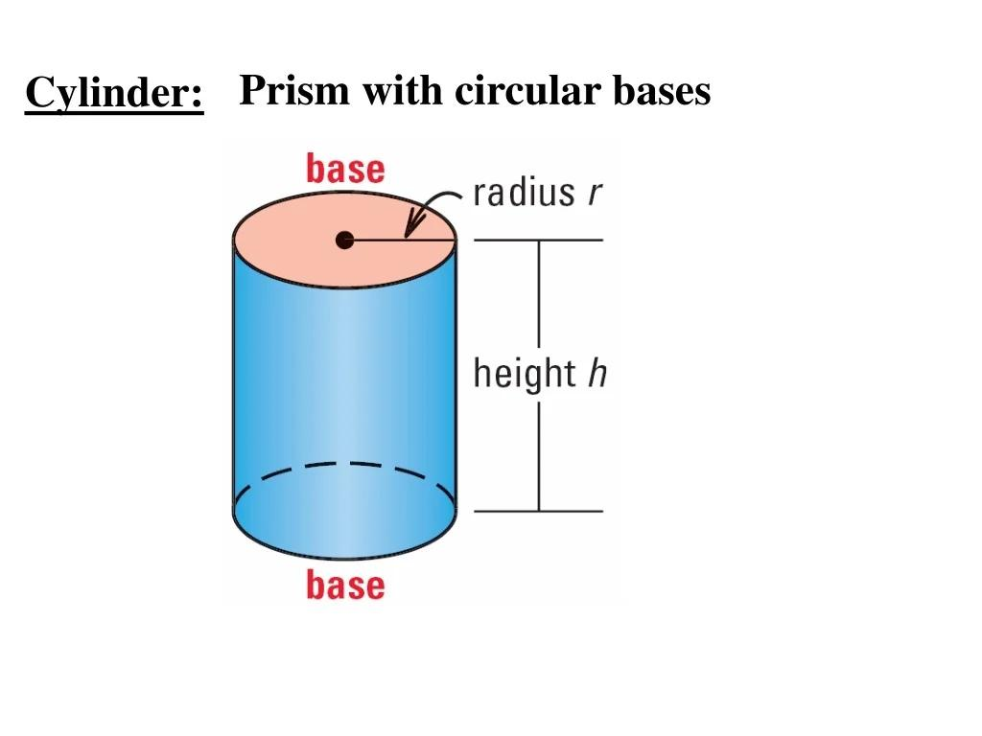
- Bottom base: The lower circular face of the cylinder.
- Center ($O$): The center of the circular base.
- Radius ($r$): The distance from the center to the circular boundary.
- Diameter ($d$): A segment passing through the center between two points on the circle.
- Circular boundary: The edge where the bottom base meets the lateral surface.
- Base plane: The plane containing the bottom circular face.
- Height ($h$): The perpendicular distance between the bottom and top base planes.

Key Characteristics
# Source: AI Source: Provided by: [Data Path: Persons Table -> ID Column: 1, Name_En Column: Motasem Essam] -> From: [ChatGPT] on [7/25/2026]
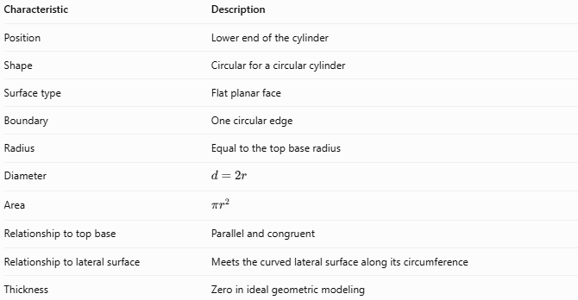
Characteristic | Description
Position | Lower end of the cylinder
Shape | Circular for a circular cylinder
Surface type | Flat planar face
Boundary | One circular edge
Radius | Equal to the top base radius
Diameter | $$d=2r$$
Area | $$πr^{2}$$
Relationship to top base | Parallel and congruent
Relationship to lateral surface | Meets the curved lateral surface along its circumference
Thickness | Zero in ideal geometric modeling
Note: In an oblique cylinder, the two bases remain parallel and congruent even though the axis is inclined relative to the base planes.

Mathematical Formulas

Area of the Bottom Base
# Source: AI Source: Provided by: [Data Path: Persons Table -> ID Column: 1, Name_En Column: Motasem Essam] -> From: [ChatGPT] on [7/25/2026]
$$\boxed{A_{\text{bottom}}=πr^{2}}$$
Where $r$ is the radius of the bottom circular base.

Area Using the Diameter
# Source: AI Source: Provided by: [Data Path: Persons Table -> ID Column: 1, Name_En Column: Motasem Essam] -> From: [ChatGPT] on [7/25/2026]
Since $r=d/2$:
$$\boxed{A_{\text{bottom}}=\frac{πd^{2}}{4}}$$

Circumference of the Bottom Base
# Source: AI Source: Provided by: [Data Path: Persons Table -> ID Column: 1, Name_En Column: Motasem Essam] -> From: [ChatGPT] on [7/25/2026]
$$\boxed{C_{\text{bottom}}=2πr=πd}$$

Combined Area of Both Bases
# Source: AI Source: Provided by: [Data Path: Persons Table -> ID Column: 1, Name_En Column: Motasem Essam] -> From: [ChatGPT] on [7/25/2026]
For a cylinder with two circular bases of radius $r$:
$$\boxed{A_{\text{two bases}}=2πr^{2}}$$
The bottom base contributes one of these two equal circular areas.

Relationship to Cylinder Volume
# Source: AI Source: Provided by: [Data Path: Persons Table -> ID Column: 1, Name_En Column: Motasem Essam] -> From: [ChatGPT] on [7/25/2026]
The volume of a cylinder equals the base area multiplied by its perpendicular height:
$$V=A_{\text{bottom}}h$$
Therefore:
$$\boxed{V=πr^{2}h}$$
This formula applies to both right and oblique circular cylinders, with $h$ measured perpendicular to the base planes.

Worked Examples
# Source: AI Source: Provided by: [Data Path: Persons Table -> ID Column: 1, Name_En Column: Motasem Essam] -> From: [ChatGPT] on [7/25/2026]
Example 1 — Calculate the Bottom Base Area
A cylinder has a bottom base radius of $7\text{ cm}$. Find its area.
Solution
$$A_{\text{bottom}}=πr^{2}$$
$$A_{\text{bottom}}=π{\left(7\right)}^{2}=49π$$
Answer:
$$\boxed{A_{\text{bottom}}≈153.94{\text{ cm}}^{2}}$$
Example 2 — Calculate the Area from the Diameter
The diameter of a cylinder's bottom base is $10\text{ cm}$.
First, find the radius:
$$r=\frac{10}{2}=5\text{ cm}$$
Then calculate the area:
$$A_{\text{bottom}}=π{\left(5\right)}^{2}$$
$$\boxed{A_{\text{bottom}}=25π≈78.54{\text{ cm}}^{2}}$$
Example 3 — Calculate the Cylinder Volume
A cylinder has a bottom base radius of $3\text{ cm}$ and a perpendicular height of $12\text{ cm}$.
$$V=πr^{2}h$$
$$V=π{\left(3\right)}^{2}\left(12\right)$$
$$\boxed{V=108π≈339.29{\text{ cm}}^{3}}$$
The bottom base area is $9π{\text{ cm}}^{2}$, and multiplying it by the height gives the volume.

Comparison with Related Cylinder Components
# Source: AI Source: Provided by: [Data Path: Persons Table -> ID Column: 1, Name_En Column: Motasem Essam] -> From: [ChatGPT] on [7/25/2026]
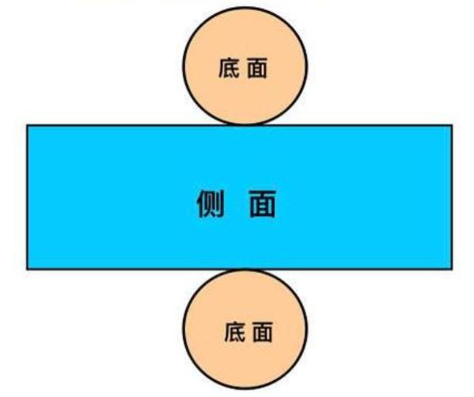
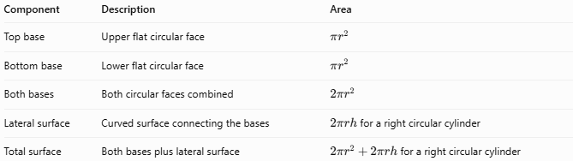
Component | Description | Area
Top base | Upper flat circular face | $$πr^{2}$$
Bottom base | Lower flat circular face | $$πr^{2}$$
Both bases | Both circular faces combined | $$2πr^{2}$$
Lateral surface | Curved surface connecting the bases | $2πrh$ for a right circular cylinder
Total surface | Both bases plus lateral surface | $2πr^{2}+2πrh$ for a right circular cylinder

Applications
# Source: AI Source: Provided by: [Data Path: Persons Table -> ID Column: 1, Name_En Column: Motasem Essam] -> From: [ChatGPT] on [7/25/2026]
- Containers: The underside of a cylindrical can, jar, or tank.
- Engineering: The lower circular face of a cylindrical component.
- Manufacturing: Measuring the diameter, circumference, and flatness of a base.
- Construction: Calculating the footprint area of cylindrical columns.
- Mathematics: Understanding base area and its role in calculating volume.

Key Points
# Source: AI Source: Provided by: [Data Path: Persons Table -> ID Column: 1, Name_En Column: Motasem Essam] -> From: [ChatGPT] on [7/25/2026]
- The bottom base is the lower flat face of a cylinder.
- For a circular cylinder, its shape is a circle.
- Its area is $πr^{2}$.
- Its circumference is $2πr$.
- It is parallel and congruent to the top base.
- The base area does not depend on the cylinder's height.
- Multiplying the base area by the perpendicular height gives the cylinder's volume.

Conclusion
# Source: AI Source: Provided by: [Data Path: Persons Table -> ID Column: 1, Name_En Column: Motasem Essam] -> From: [ChatGPT] on [7/25/2026]
The bottom base of a cylinder is the lower planar face, circular in a circular cylinder. It has the same dimensions and area as the top base and is fundamental to calculating a cylinder's volume and surface measurements.

